对空间EDA
摘要：
本报告对 2015–2024 年芝加哥犯罪事件数据进行空间探索性分析。我们基于经纬度点位使用 hexbin（对数分箱）与热力图可视化整体空间密度，并在行政区划层面（District、Community Area）统计高发区域。同时，按犯罪类型（如 THEFT、BATTERY、ROBBERY）与发生地点类型（STREET、APARTMENT、RESIDENCE）进行分层空间对比，检验空间分布的异质性。最后，采用约 1km 尺度的网格化（经纬度保留两位小数）挖掘热点网格，并分析热点在年度上的持久性，为后续时空预测建模与特征工程提供依据。

Abstract:
This report conducts a spatial exploratory analysis of Chicago crime incident data from 2015 to 2024. We visualize overall spatial density using hexbin (log-scale binning) and heatmaps based on latitude/longitude points, and identify high-incidence areas at the administrative level (District, Community Area). Simultaneously, we conduct stratified spatial comparisons by crime type (e.g., THEFT, BATTERY, ROBBERY) and location type (STREET, APARTMENT, RESIDENCE) to examine spatial distribution heterogeneity. Finally, we identified hotspot grids using approximately 1km-scale grids (with latitude and longitude retained to two decimal places) and analyzed the persistence of these hotspots across years. This provides a foundation for subsequent spatio-temporal prediction modeling and feature engineering.

1. 引言
1.1 背景与动机
城市犯罪具有显著的空间非均匀性，常表现为热点区域（hotspots）与集聚现象。对后续的犯罪预测、警力资源配置与风险预警而言，识别空间热点、理解热点的稳定性与不同犯罪场景的空间差异是关键步骤。因此，本项目需要通过空间 EDA 给出数据的空间结构概览，并提炼可用于建模的空间规律与特征设计方向。

1. Introduction
1.1 Background and Motivation
Urban crime exhibits significant spatial heterogeneity, often manifesting as hotspots and clustering phenomena. For subsequent crime forecasting, police resource allocation, and risk warning, identifying spatial hotspots, understanding their stability, and recognizing spatial variations across different crime scenarios are critical steps. Therefore, this project requires spatial exploratory data analysis (EDA) to provide an overview of the data's spatial structure and to extract spatial patterns and feature design directions applicable for modeling.

1.2 分析目标
本空间 EDA 主要回答以下问题：
数据在城市空间上是否存在明显热点？热点形态是单中心还是多中心？
在行政区划层面（District、Community Area），哪些区域案件量最高？
不同犯罪类型（THEFT/BATTERY/ROBBERY）是否具有不同的空间热点结构
不同发生地点类型（STREET/APARTMENT/RESIDENCE）是否体现不同的空间分布模式？
在约 1km 的微空间网格尺度上，哪些网格最“热”？这些热点网格是否在不同年份持续出现（持久性）？

1.2 Analysis Objectives
This spatial EDA primarily addresses the following questions:
Does the data exhibit distinct spatial hotspots within the urban area? Are these hotspots unipolar or multipolar in form?
At the administrative district level (District/Community Area), which areas have the highest case volumes?
Do different crime types (THEFT/BATTERY/ROBBERY) exhibit distinct spatial hotspot structures?
Do different incident location types (STREET/APARTMENT/RESIDENCE) exhibit distinct spatial distribution patterns?
At the micro-spatial grid scale of approximately 1km, which grids are the “hottest”? Do these hotspot grids persist across different years (persistence)?

1.3 分析范围与假设
本报告使用清洗后的事件级数据（incident-level），时间跨度为 2015–2024。
空间可视化（hexbin/热力图）反映的是事件数量密度（counts density），并非人口归一化后的风险率（per-capita risk）。
网格化方法使用 round(0.01) 将经纬度离散为约 1km 尺度的空间单元，用于 EDA 的粗粒度热点挖掘（并非严格等面积投影网格）。
由于事件数规模较大，采用 hexbin（对数分箱）避免散点过密导致的可读性问题。

1.3 Scope and Assumptions
This report utilizes cleaned incident-level data spanning the period 2015–2024.
Spatial visualizations (hexbin/heatmap) reflect incident count density, not population-normalized risk rates.
The grid method uses round(0.01) to discretize latitude and longitude into spatial units of approximately 1km scale for coarse-grained hotspot detection in EDA (not strictly equal-area projection grids).
Given the large number of incidents, hexbin (logarithmic binning) is employed to avoid readability issues caused by excessive scatter point density.

2. 数据集描述
2.1 数据规模与时间范围
• 数据行数与列数：2,469,034 行 × 21 列
• 年份范围：2015–2024
• 主要类别字段的唯一值数量：

2. Dataset Description
2.1 Data Scale and Time Range
• Number of rows and columns: 2,469,034 rows × 21 columns
• Year range: 2015–2024
• Number of unique values in primary category fields:
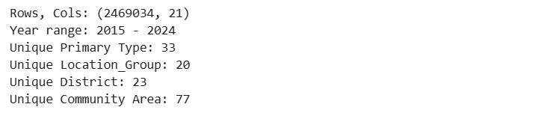

2.2 关键字段说明（与空间 EDA 相关）
空间字段：Latitude、Longitude、District、Community Area（以及 Ward/Beat 等，如存在）
犯罪属性：Primary Type、Description、IUCR
场景字段：Location_Group（由原始 Location Description 清洗/归并得到）
结果字段：Arrest_Flag、Domestic_Flag
时间字段：Date、Year、Month、DayOfWeek、Hour

2.2 Key Field Descriptions (Related to Spatial EDA)
Spatial Fields: Latitude, Longitude, District, Community Area (and Ward/Beat, if applicable)
Crime Attributes: Primary Type, Description, IUCR
Scenario Fields: Location_Group (derived from cleaned/merged original Location Descriptions)
Result Fields: Arrest_Flag, Domestic_Flag
Time Fields: Date, Year, Month, DayOfWeek, Hour

2.3 基本分布与数据质量
Top 犯罪类型（样例）：THEFT、BATTERY、CRIMINAL DAMAGE、ASSAULT、…
Top 发生地点类型（样例）：STREET、APARTMENT、RESIDENCE、SIDEWALK、…
缺失率（截图显示）：关键空间字段 Latitude/Longitude 基本无缺失（或极低），支持后续空间可视化与热点分析

2.3 Basic Distribution and Data Quality
Top Crime Types (Examples): THEFT, BATTERY, CRIMINAL DAMAGE, ASSAULT, …
Top Location Types (Examples): STREET, APARTMENT, RESIDENCE, SIDEWALK, …
Missing Data Rate (as shown in screenshot): Critical spatial fields Latitude/Longitude show minimal to no missing values, supporting subsequent spatial visualization and hotspot analysis.
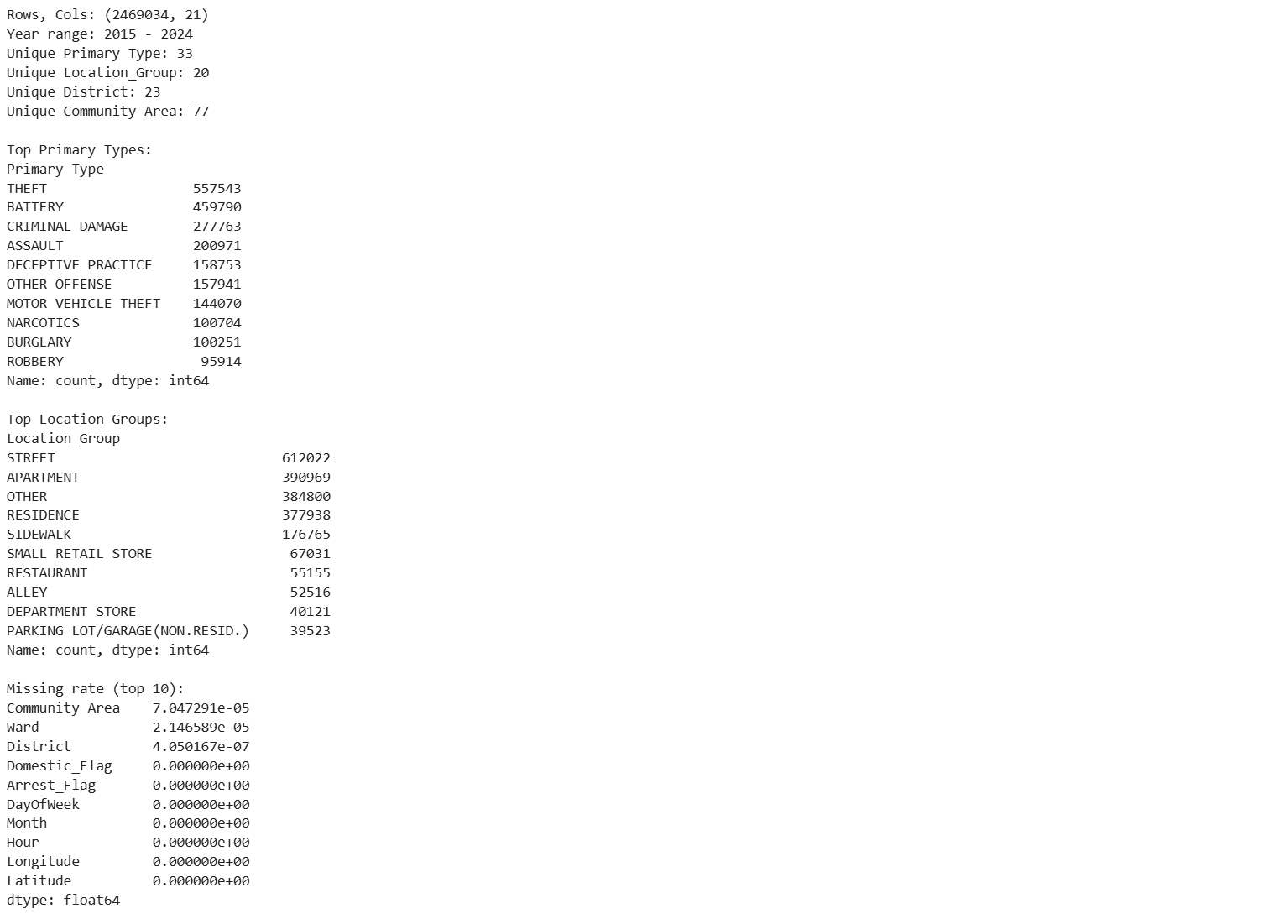

3. 空间分布与热点
为避免百万级散点重叠，使用 hexbin（对数分箱） 与 热力图（Heatmap）展示空间密度。结果显示：犯罪在空间上明显非均匀，存在多中心热点与局部带状/走廊式高密度区域，边缘整体较冷但仍有(iv)局部热点。地图热力图（Heatmap / KDE 风格）：将点位密度平滑并叠加到底图上，增强地图语境下的可读性，用于展示热点大致位置与多中心结构。

3. Spatial Distribution and Hotspots
To avoid overlapping millions of scatter points, hexbin (logarithmic binning) and heatmaps were employed to visualize spatial density. Results reveal: Crime exhibits distinct spatial non-uniformity, featuring multi-centered hotspots and localized strip/corridor-like high-density zones. While peripheries appear generally cooler, (iv) localized hotspots persist. Map Heatmap (Heatmap / KDE Style): Point densities are smoothed and overlaid onto the base map to enhance readability within the cartographic context, illustrating approximate hotspot locations and the multi-center structure.

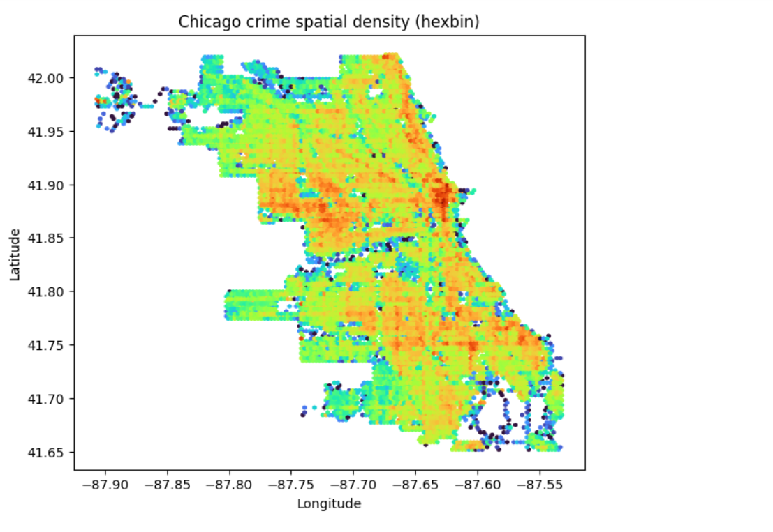
说明：该类图反映的是事件数量密度（counts density），未按人口/暴露量归一化，因此更适合“热点定位”而非“人均风险比较”。

Note: This type of map reflects event counts density and is not normalized by population or exposure levels. Therefore, it is more suitable for “hotspot identification” rather than “comparing per capita risk.”

4 行政区划层面高发区域（District / Community Area）
对 District 与 Community Area 进行事件数聚合并取 Top10：District 高发分布在多个区之间；Community Area 的头部集中更明显（部分区域显著高于其他区域），说明在更细单元下聚集更突出。

4. High-Incidence Areas at the Administrative Division Level (District/Community Area)
Aggregate incident counts for Districts and Community Areas and rank the Top 10:
- District-level high-incidence areas are distributed across multiple districts;
- Community Area rankings show more pronounced concentration at the top (with some areas significantly higher than others), indicating more prominent clustering at finer granularity.

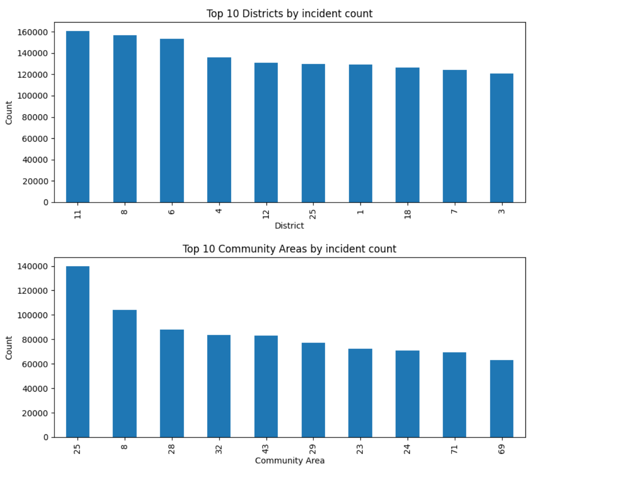说明：District 级别的案件量“没有极端一枝独秀”，而是多区并列高发，高危犯罪普通犯罪都很多；Community Area 粒度显示更强的头部集中（热点更清晰）。

Note: At the District level, crime rates do not show extreme outliers, but rather multiple districts share high incidence rates, with both high-risk and common crimes occurring frequently. At the Community Area level, data reveals stronger concentration at the top end (clearer hotspots).

5 分层空间异质性（犯罪类型 / 发生地点类型）
5.1 按犯罪类型（THEFT / BATTERY / ROBBERY）
分别对 THEFT、BATTERY、ROBBERY 绘制 hexbin 密度图并比较高发区。结果表明不同犯罪类型的热点结构不完全重合：

5 Spatial Heterogeneity by Crime Type / Location Type
5.1 By Crime Type (THEFT / BATTERY / ROBBERY)
Hexbin density maps were generated separately for THEFT, BATTERY, and ROBBERY to compare high-incidence zones. Results indicate that hotspot patterns for different crime types do not fully overlap:

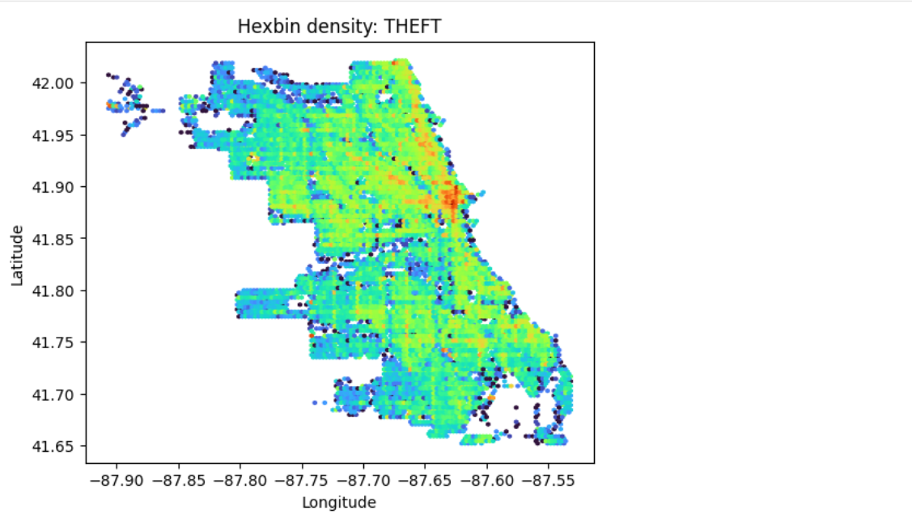
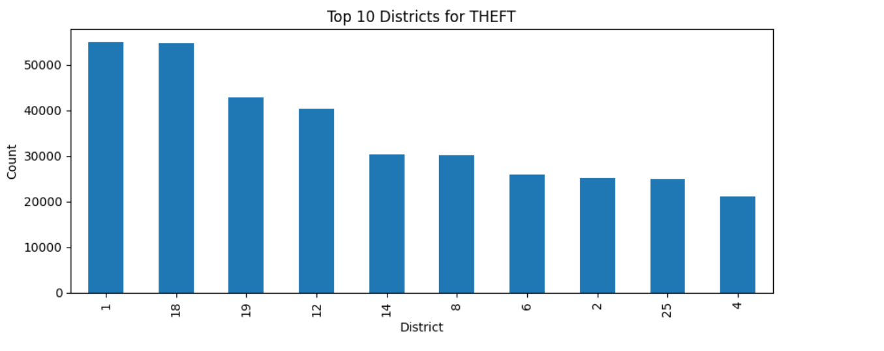
1) THEFT
在城市中心/靠近湖岸的中北部位置出现一条明显的高密度带（红/橙色集中）
盗窃与“人流密度/商业活动/交通枢纽”相关性更强，因此更集中在少数高活动 District（图中头部明显）。

A distinct high-density band (concentrated in red/orange) emerges in the central/northern-central area near the lakefront.
Theft shows a stronger correlation with “population density/commercial activity/transportation hubs,” thus concentrating more in a few high-activity districts (evidently highlighted in the map's upper section).

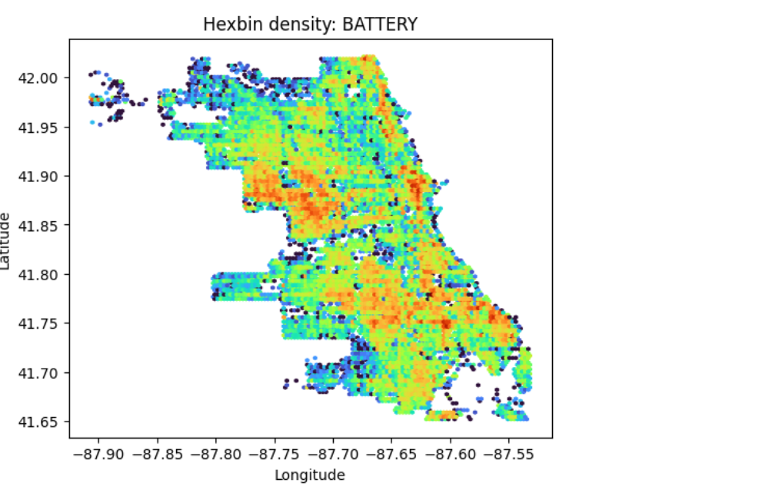
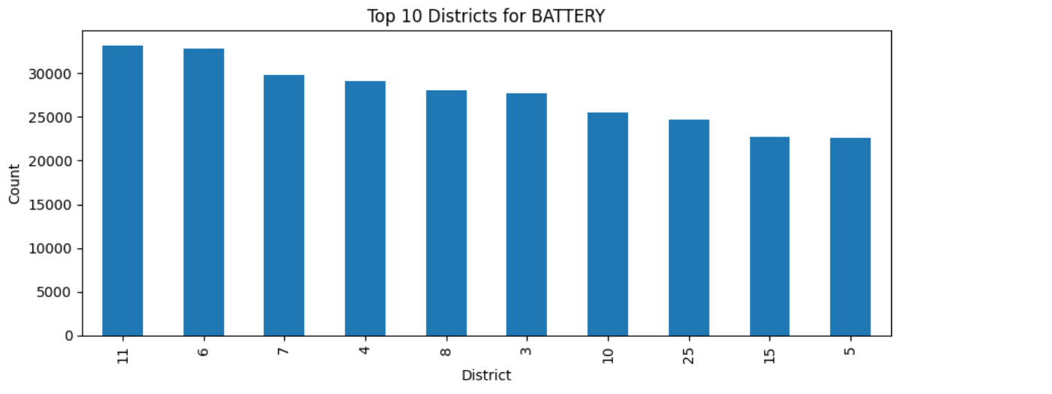
2) BATTERY（人身伤害/殴打）
热点不是单一中心，而是出现多个较大的橙/红色区域块，尤其在城市的中部偏西、以及南部区域更显著。
BATTERY 这类“人身冲突/暴力相关”犯罪，往往表现为社区型、多中心聚集；相比 THEFT（更偏活动核心/商业交通），BATTERY 更可能与居住社区、邻里冲突、夜间活动环境相关，因此热点更分散且出现在多个 District。

Hotspots are not singular centers but multiple large orange/red clusters, particularly prominent in the midwestern and southern parts of the city.
BATTERY crimes—those involving physical altercations or violence—typically manifest as community-based, multi-center clusters. Unlike THEFT (which tends to cluster around activity hubs/commercial transportation), BATTERY is more likely linked to residential neighborhoods, neighborhood conflicts, and nighttime environments. Consequently, its hotspots are more dispersed and appear across multiple districts.

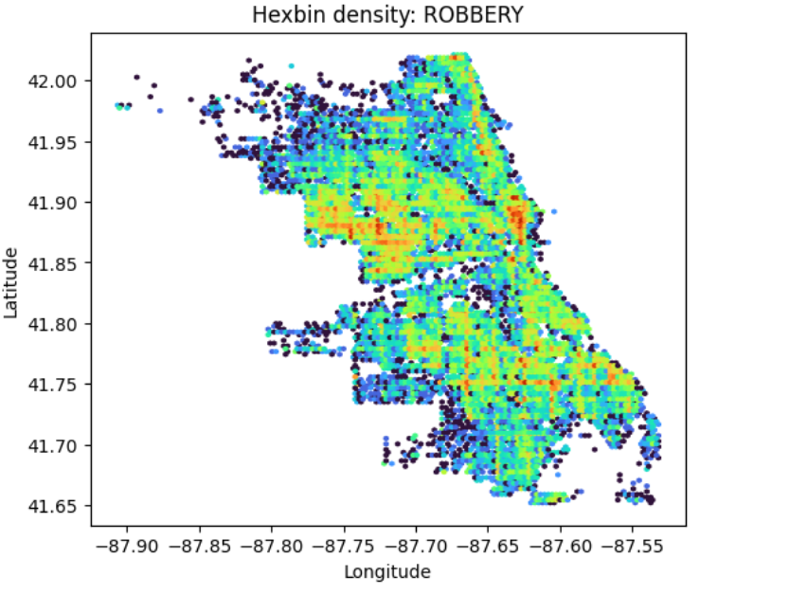
3) ROBBERY（抢劫）
图上出现了更多深色/空白（代表很多网格计数低或接近 0），说明 ROBBERY 更集中在少数地点，整体覆盖面更小。

The map shows more dark areas/blank spaces (indicating numerous grid cells with low or near-zero counts), suggesting that ROBBERY is concentrated in fewer locations with overall reduced coverage.

5.2 按发生地点类型（STREET / APARTMENT / RESIDENCE）
分别对 STREET、APARTMENT、RESIDENCE 绘制 hexbin 密度图。结果显示：STREET 分布更广且更连续（更像走廊扩散）；APARTMENT 更局部、点状集聚；RESIDENCE 更偏块状社区聚集。

5.2 By Location Type (STREET / APARTMENT / RESIDENCE)
Hexbin density plots were generated separately for STREET, APARTMENT, and RESIDENCE. Results indicate: STREET incidents exhibit broader and more continuous distribution (resembling corridor diffusion); APARTMENT incidents show more localized, point-like clustering; RESIDENCE incidents tend toward block-like community aggregation.

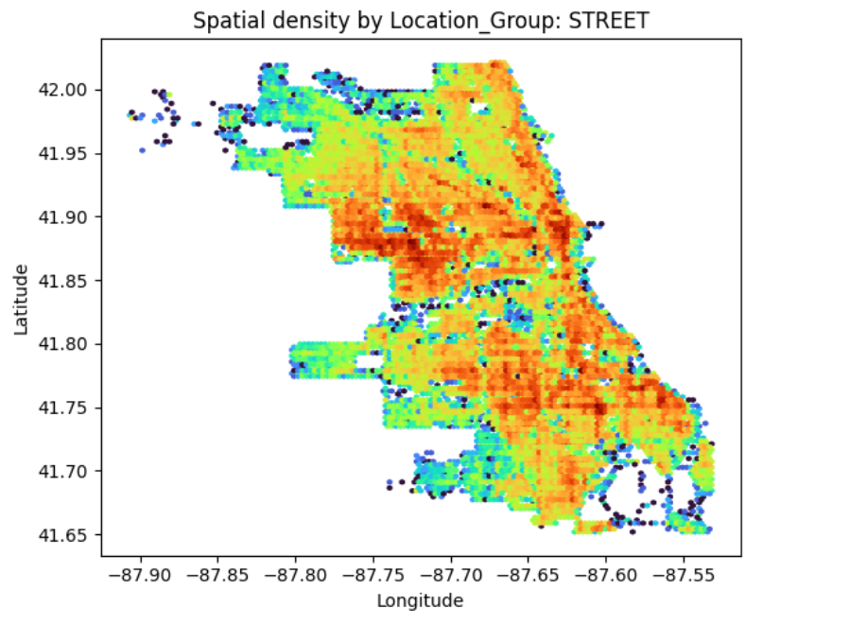
- STREET：覆盖最广、最“连续”的高发带

1) STREET: The most extensive and “continuous” high-incidence zone
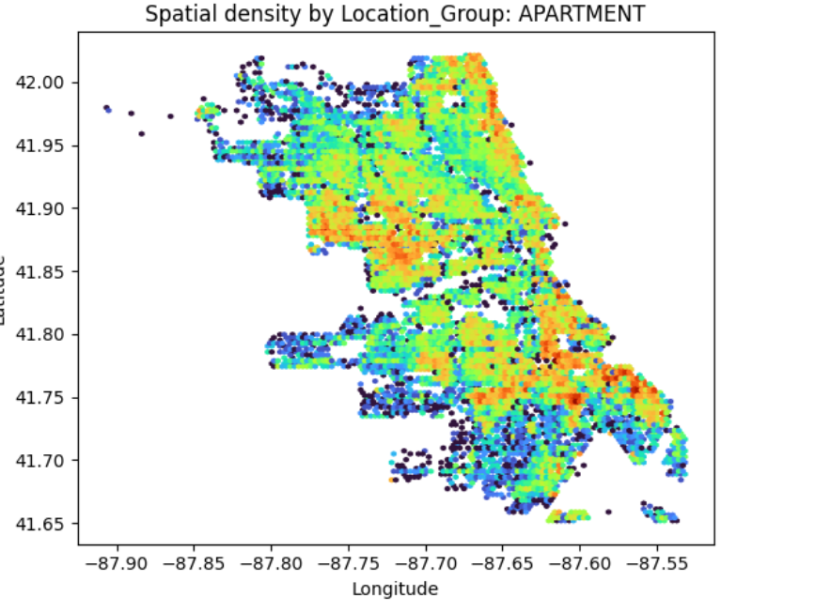
- APARTMENT：更“稀疏”、更“点状/局部”的热点（并非全城均匀）

2) APARTMENT: Hotspots that are more “sparse” and more “scattered/localized” (not uniformly distributed throughout the city)
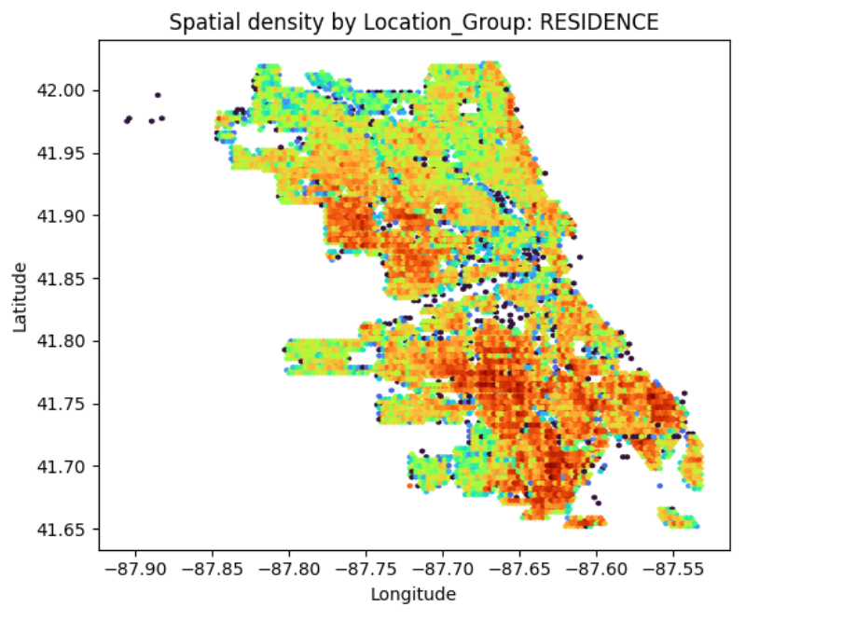
- RESIDENCE：典型“社区块状聚集”，南部更明显（居住社区特征强）

3) RESIDENCE: Characterized by typical “community block clusters,” more pronounced in the southern area (strong residential community features).

6 网格化热点与年度持久性（量化验证）
采用经纬度保留两位小数作为近似网格（约 1km 尺度），统计每个 (lat_bin, lon_bin) 的事件数并排序。Top 网格结果显示：热点高度集中在 经度约 -87.63 附近且纬度 41.87–41.90 的连续网格带（核心热点走廊），同时在 -87.72~-87.75 等区域存在次级热点簇。

6 Grid-Based Hotspots and Annual Persistence (Quantitative Validation)
Using latitude and longitude with two decimal places as approximate grid coordinates (approximately 1km scale), the number of events in each (lat_bin, lon_bin) bin is counted and sorted. Top grid results reveal: Hotspots are highly concentrated near longitude approximately -87.63 and within a continuous grid band spanning latitudes 41.87–41.90 (core hotspot corridor), with secondary hotspot clusters also present in areas such as -87.72 to -87.75.
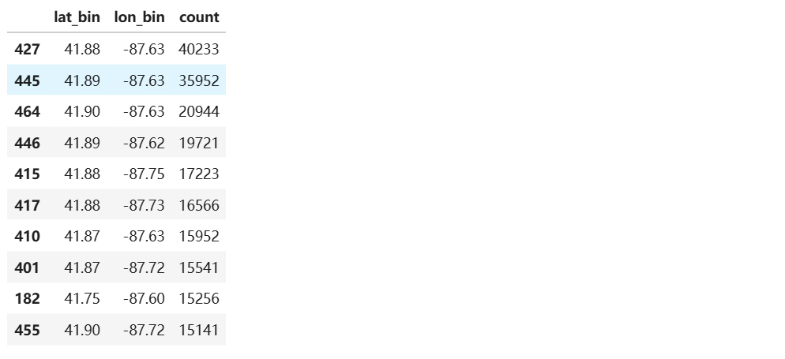
说明：将经纬度四舍五入到 0.01°作为近似网格后，案件在微空间单元上呈现强烈的头部集中。Top 网格主要集中在经度约 -87.63 且纬度 41.87–41.90 的连续带状区域，显示出明显的核心热点走廊；此外在 -87.72~-87.75 一带及南部靠东区域存在次级热点簇。仅 Top 1 网格就贡献约 1.6% 的总案件量，表明犯罪风险在空间上高度不均衡。

Note: After rounding latitudes and longitudes to 0.01° for approximate gridding, cases exhibit strong head clustering within micro-spatial units. The top grid is primarily concentrated in a continuous strip-like area around longitude -87.63 and latitudes 41.87–41.90, revealing a distinct core hotspot corridor. Additionally, secondary hotspot clusters exist in the -87.72 to -87.75 range and in the southeastern region. Top 1 alone accounted for approximately 1.6% of total cases, indicating highly uneven spatial distribution of crime risk.

进一步按年统计每年 Top10 网格，发现核心热点网格在多个年份中反复出现，说明热点具有明显持久性；同时核心网格年度计数存在变化趋势（可表现为强度增强/减弱），且热点会在相邻网格间出现“邻格溢出/轻微漂移”（与空间连续性及网格离散边界有关）。

Further analysis of the annual Top 10 grids reveals that core hotspot grids recur across multiple years, indicating pronounced persistence of these hotspots. Concurrently, the annual counts of core grids exhibit fluctuating trends (manifesting as intensification or weakening), while hotspots demonstrate “neighboring grid spillover/slight drift” between adjacent grids (attributable to spatial continuity and discrete grid boundaries).
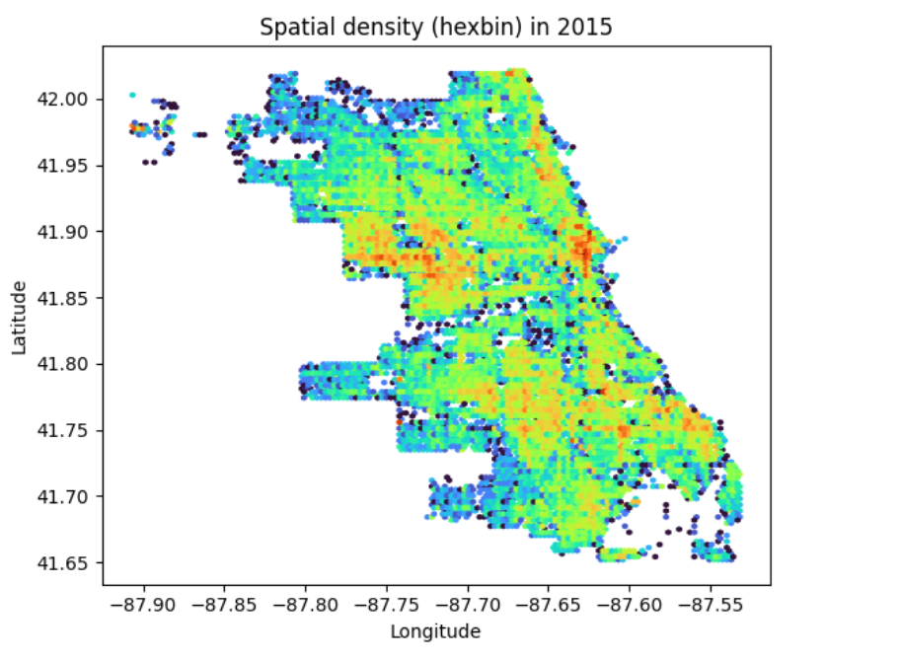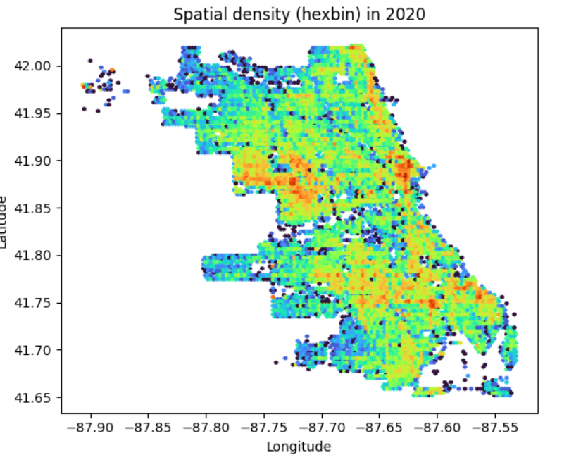
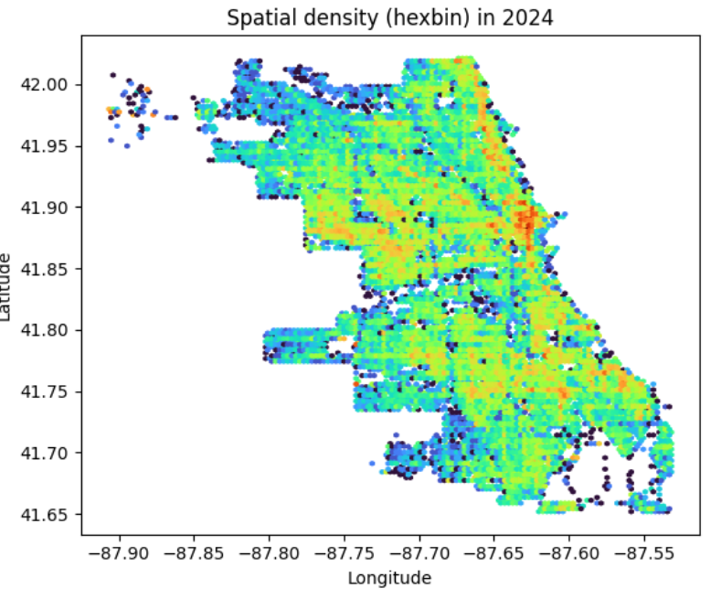
按年份对比的空间 hexbin 密度图显示，芝加哥犯罪热点在空间上具有明显的持久性（persistence）：主要高密度区域在 2015、2020、2024 年均出现在相近位置，说明空间风险结构相对稳定。然而，各年份热点的强度与局部形态存在变化（intensity drift），部分区域在特定年份呈现更强的聚集或范围扩张/收缩。该结果表明后续风险预测建模应结合空间与时间信息，例如使用过去 7/30 天的滚动事件计数、以及时变的空间风险特征，以同时捕捉长期空间结构与短期波动。

Spatial hexbin density maps comparing different years reveal that Chicago's crime hotspots exhibit distinct spatial persistence: major high-density areas appeared in similar locations in 2015, 2020, and 2024, indicating a relatively stable spatial risk structure. However, intensity drift is observed in the strength and local morphology of hotspots across years, with certain areas exhibiting stronger clustering or spatial expansion/contraction in specific years. This finding suggests that subsequent risk forecasting models should integrate both spatial and temporal information—such as rolling event counts over the past 7/30 days and time-varying spatial risk characteristics—to simultaneously capture long-term spatial patterns and short-term fluctuations.
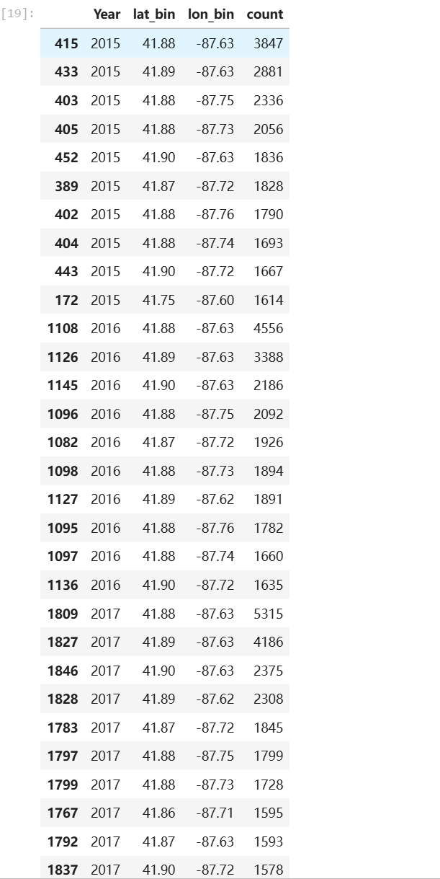
说明：按年统计每年 Top10 网格后可以观察到明显的热点持久性。核心热点网格在 2015–2017 年连续位列年度 Top1/Top2，且集中在经度约 -87.63、纬度 41.88–41.90 的相邻网格带，表明该热点在空间上位置稳定。同时核心热点强度呈上升趋势：例如 (41.88,-87.63) 的年度计数从 2015 的 3847 增至 2016 的 4556，再增至 2017 的 5315，显示热点强度增强。除核心带外，-87.72~-87.75 一带的多个网格也在各年反复出现，体现出多簇稳定热点结构，并存在相邻网格间的溢出与轻微漂移。

Note: Annual statistics of the Top 10 grids reveal distinct hotspot persistence. The core hotspot grid consistently ranked among the annual Top 1/Top 2 from 2015 to 2017, concentrated in an adjacent grid band centered at approximately longitude -87.63 and latitude 41.88–41.90, indicating stable spatial positioning. Simultaneously, the intensity of the core hotspot exhibits an upward trend: for instance, the annual count for (41.88, -87.63) increased from 3,847 in 2015 to 4,556 in 2016, and further to 5,315 in 2017, demonstrating heightened hotspot intensity. Beyond the core zone, multiple grid cells within the -87.72 to -87.75 range also repeatedly appeared across years, reflecting a multi-cluster stable hotspot structure with spillover and slight drift between adjacent grid cells.

结论
基于 2015–2024 年芝加哥犯罪事件数据的空间 EDA，可以确认犯罪分布具有显著的空间非均匀性：整体呈现多中心热点与局部走廊式高密度带，少数区域贡献了不成比例的案件量。在行政区划层面，District 与 Community Area 的高发排序进一步印证热点在管理单元上的集中性，但不同尺度下的“头部集中程度”存在差异。分层结果显示明显空间异质性：不同犯罪类型（如 THEFT、BATTERY、ROBBERY）与不同发生地点类型（STREET、APARTMENT、RESIDENCE）对应的热点形态和高发区域并不完全一致，说明“类型/场景”是解释空间差异的重要维度。通过约 1km 网格化统计，核心热点网格在多年中反复出现，体现出较强的年度持久性，同时热点强度随年份存在变化，并伴随邻近网格的溢出与轻微漂移。总体而言，这些发现支持后续建模采用更细空间单元（如社区或网格）并引入多尺度空间特征，同时将 Primary Type 与 Location_Group 作为关键分层/交互特征；但需要注意本报告主要基于事件数密度，未进行人口或暴露量归一化，因此结论更适用于热点识别与预测建模输入设计，而非直接推断人均风险。

Conclusion
Spatial exploratory data analysis (EDA) of Chicago crime incident data from 2015 to 2024 confirms significant spatial non-uniformity in crime distribution: overall patterns reveal multi-centered hotspots and localized corridor-like high-density zones, with a few areas contributing disproportionately to case volumes. At the administrative level, high-incidence rankings for Districts and Community Areas further validate the concentration of hotspots within management units, though the degree of “head concentration” varies across scales. Hierarchical analysis reveals pronounced spatial heterogeneity: hotspot patterns and high-incidence zones vary across crime types (e.g., THEFT, BATTERY, ROBBERY) and location types (STREET, APARTMENT, RESIDENCE), indicating that “type/scenario” is a critical dimension explaining spatial disparities. Using approximately 1km grid-based statistics, core hotspot grids repeatedly emerge across multiple years, demonstrating strong annual persistence. Simultaneously, hotspot intensity varies by year, accompanied by spillover effects to neighboring grids and slight drift. Overall, these findings support subsequent modeling using finer spatial units (e.g., neighborhoods or grids) and incorporating multi-scale spatial features, while treating Primary Type and Location_Group as key stratification/interaction variables. However, note that this report primarily relies on event density without population or exposure normalization. Consequently, conclusions are more applicable to hotspot identification and predictive modeling input design rather than direct inference of per capita risk.

